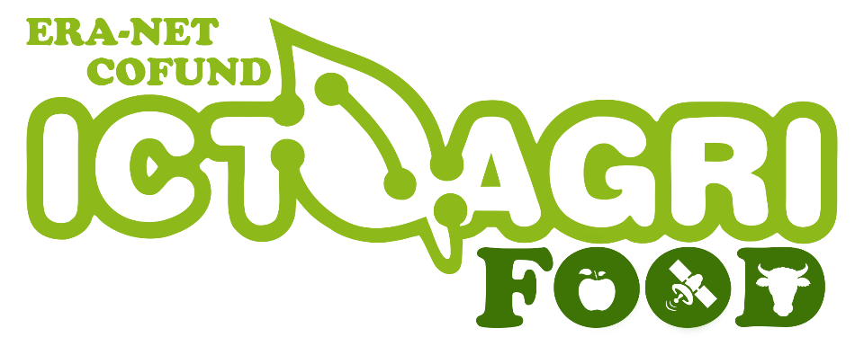

2019 Joint Call

ON ICT-enabled agri-food systems

Complaint-Template

Applicants may submit a review request no later than 30 days after receiving the eligibility/evaluation result. Only one request per proposal will be considered at each evaluation stage. Coordinators should coordinate the need for complaints.

Complaints can be related to:
- unfair treatment,
- eligibility check procedure,
- evaluation procedure.

The scientific and technical judgement of the international experts will not be called into question.

An independent observer will examine the requests for review submitted by the applicants. If a complaint concerning an eligibility issue is judged valid by the observer, the project will be re-integrated into the selection process. If a complaint concerning an evaluation issue is judged valid by the observer, the re-evaluation of the project will be carried out only if the shortcoming could modify the selection/funding decision. The decision of the observer and the evaluation score following any re-evaluation will be regarded as definitive.

To submit a complaint, please fill out Page 2 of this template, sign it and send it to: ict-agri-food-2019@ble.de

Complaint
I submit an official complaint related to unfair treatment, eligibility or evaluation procedure of the following Call:
ICT-AGRI-FOOD 2019 Joint Call
ERA-NET COFUND on ICT-enabled agri-food systems

Acronym of the Project:
Full Title of the Project:
Name of the Complainant:
Role in the Project:
Email Address:
Please describe in detail the cause for your complaint:

This project has received funding from the European Union's Horizon 2020 research and innovation programme under grand agreement no 862665 ICT-AGRI-FOOD.

